Contents
Preparation 2
Installation 3
First startup and initial configuration 6
Network and PC considerations 10
Why use DHCP and DNS? 10
Setting up DHCP and DNS server 10

Preparation

- Review your PC. It should have 5GB free space and it should not already have a number of applications that tie up TCP/IP ports.
  - Do a restart on the PC to ensure that all connections are closed.
  - Check you disk and make sure that you have at least 5GB free space
  - Open a DOS prompt and type “netstat” (see below for an example). If you have a large number of lines (representing TCP/IP connections), you may want to consider a PC with less “going on.”

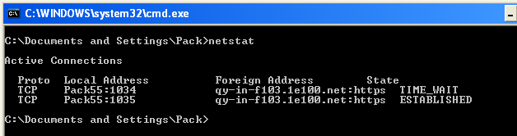

- Download and kick off the XAMPP executable.
  - Point your browser to http://www.apachefriends.org/en/xampp-windows.html
  - You should download the most current version. These instructions were created using version 1.7.2. Newer versions may have some minor differences you should watch for.
  - Download the “self-extracting RAR archive” from the download site to a temporary folder

Installation

- Once the file is downloaded, double click on it to kick off the install. You will get a download panel that looks like this. Leave all of the defaults and click install.

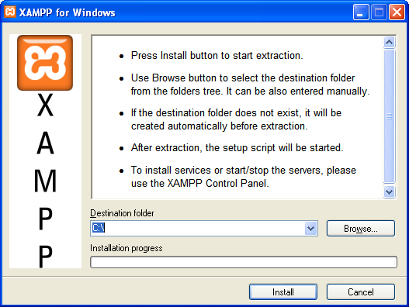

4. The program will install the programs needed, and then present you with a series of questions in DOS prompts. These are all shown below; answer all questions with the default value as shown.

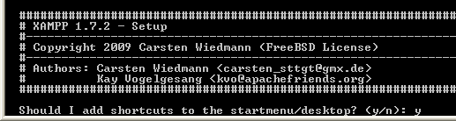

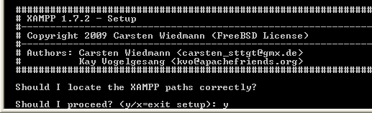

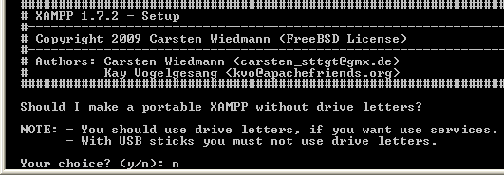
- The process will finish and tell you to hit the Enter button to continue.
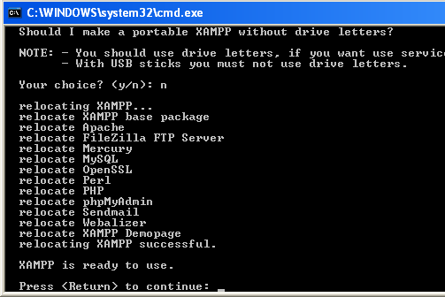
- You will get a confirmation of the time zone you are in. Press enter.
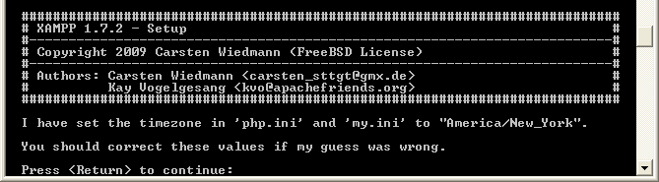
- You will get a menu of option. Just enter an “x” to exit and press the Enter key.
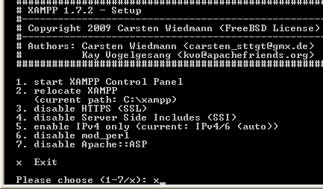
- You will find that the XAMPP installation has planted an icon on your desktop. You will use this to start and stop the XAMPP functions.
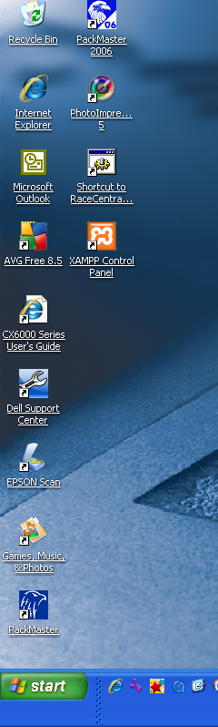

First startup and initial configuration

- Click on the desktop XAMPP icon to startup the XAMPP control panel. It should start an application like this:
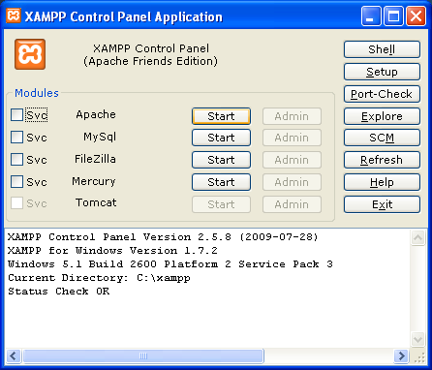

- Click on the Start button next to “Apache.” If you get a message from your firewall software like this, be sure to “unblock” or “permit” access to this application. Similarly, start the MySQL application and FileZilla application.

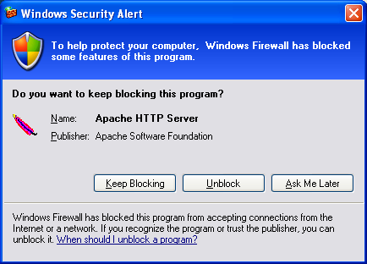

- If everything is successfully installed, the XAMPP control panel will look like the graphic below (green “running” text next to the applications) and you will be able to launch the administrative functions for apache and MySQL in browser windows.
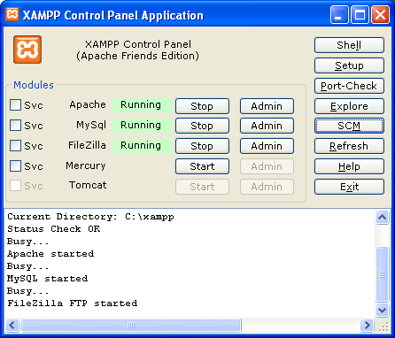

- Point your browser to this URL: http://localhost/xampp/. You may be prompted to select a language.
- Now point your browser to http://localhost/security/xamppsecurity.php. You will see a screen like the image below:
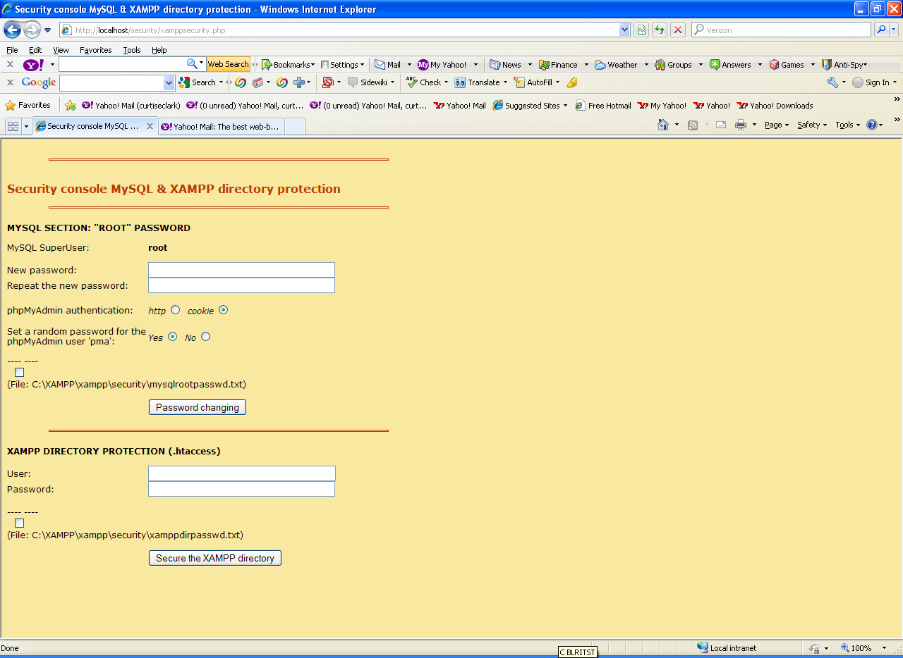
- First assign and repeat the MySQL password for the “root” superuser. For purposes of these instructions, assign a value of sqlrootpw (case sensitive). Click the button titled “Password changing”. This will be your new MySQL “root” password from now on.
- Next, assign a user and password for XAMPP Directory Protection. For purposes of these instructions, use these values. Then click the button titled “Secure the XAMPP directory.” This will be your XAMPP ID and password from now on.
User: xampp (all lower case)
Password: XAMPPpw (case sensitive)
- Go back to the XAMPP control panel and stop then restart both the Apache and MySQL applications.
- Copy the PHP Programs and objects. Copy the directory (PWD2010v1 as of this writing) into the c:\xampp\htdocs folder on the server you have just setup.
- Using windows explorer, locate the file called “index.php” in the directory c:\xampp\htdocs\. Open the file with WordPad.
- Make these changes to the file – add highlighted text as shown below. These changes will facilitate directing people to the login page for the PWD application.
<?php
if (!empty($_SERVER['HTTPS']) && ('on' == $_SERVER['HTTPS'])) {
$uri = 'https://';
} else {
$uri = 'http://';
}
$uri .= $_SERVER['HTTP_HOST'];
// header('Location: '.$uri.'/xampp/');
header('Location: '.$uri.'/PWD2010v1/');

exit;
?>
Something is wrong with the XAMPP installation :-(
- Using windows explorer, locate the file called “C__xampp_htdocs.config.inc.php” in the directory c:\xampp\htdocs\pwd2009\includes. Open the file with WordPad.
- Make these changes to the configuration to fit the needs. Adjust any other passwords if you used other values.
$config['db'] = 'mysql';
$config['dbhost'] = 'localhost';
$config['dbport'] = 3306;
$config['dbname'] = 'pwd2010';
$config['dblogin'] = 'root';
$config['dbpass'] = 'sqlrootpw';
$config['encoding'] = 'utf-8';
$config['rows_per_page'] = 20;
$config['pager_items'] = 10;
$config['admin_id'] = "root";
$config['admin_password'] = "sqlrootpw";
$config['dictionary'] = 'words';
$config['autoRefreshON'] = 'YES';
$config['autoRefreshDuration'] = 10; $config['autoRefreshVideoDuration'] = 15; $config['autoRefreshHeatDisplayCount'] = 3; $config['autoRefreshRacerPointsCount'] = 2; $config['autoRefreshHeatVideoClip'] = 1;
$config['autoRefreshOnDeck'] = 3;
$config['Page_Heading'] = 'Pack 55 Pinewood Derby Race';

- Locate functions_datebase.php in the \includes directory and open it to edit. Make these changes:

- Ensure that you can access the application. Point your browser to http://localhost/. You should get the main PWD application sign on screen.
- Build and initially populate the database. Do this by pointing your browser to this URL http://localhost/pwd2010v1/nuke.php. Remember – if you return to this URL at a later time, you will completely reset the database and LOSE any data you may have created. This is the ONLY time you should use this URL. You will get a screen listing the tables that were created.
- Return and login by pointing your browser to http://localhost/. You can begin by using the admin ID/PW = john/123123.

Network and PC considerations

Why use DHCP and DNS?
It will be assumed that you install the DHCP and DNS server indicated in these instructions. If you do not, you will need to provide URLs to your users that will look like: http://<ip address of the XAMPP server>.
A DHCP server is simply an application that is responsible for handing out valid IP addresses to PCs that join the network that the server is part of. Using a DHCP server means that you can easily add PCs to your temporary network without needing to worry about assigning an IP address manually.
A DNS server is responsible for resolving the URL typed into the address box of a browser into the actual address of the computer that the URL represents. In these instructions, the DNS server is used mainly to provide a simple URL to provide your users. Following these steps, you will just instruct your users to point their browsers to http://pwd – and the application will come up.
If you are using an established network, you should share this section with the network administrator in order to find out if there are alternate tasks that they will provide for you.

Setting up DHCP and DNS server
It is recommended that a pc be assigned the duty of providing DHCP/DNS services that will sit in the network and not be rebooted or disconnected from the network for any reason. A PC that is going to sit and flash pictures on a projector is a good candidate for this task.
All of these tasks assume:
- You are logged into the PC that will be used as the DHCP and DNS server.
- You are logged in as the administrator
- Locate the Dual DHCP DNS Server software by pointing your browser to http://sourceforge.net/projects/dhcp-dns-server/
- Download and install the windows executable
- Assign a “static” IP address to the PC. These instructions will work “as-is” if you will be creating a stand-alone network. If you are fitting into an existing network, you may need to adjust these as needed. Further, these instructions assume that this stand-alone network connects to another network that provides internet access. This may not be appropriate for your situation.
- Start->Control Panel->Network Connections
- Right-click on your network interface and select “Properties
- Scroll down the list of properties and select TCP/IP
- Assign values to the screen that looks like this:
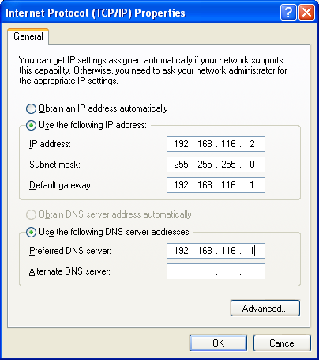
- IP address – use this value unless you are part of an established network
- Subnet mask – use this value unless you are part of an established network
- Default gateway – assign the IP address of the router that interconnects your network to the internet if one exists. Otherwise do not assign this box a value.
- Preferred DNS server(s) – assign the IP address of the DNS provider if one exists. Otherwise do not assign this box a value.
- Locate the DHCP/DNS configuration file and make these updates. The file is named dualserver.ini and is located in the C:\Program Files\DualServer directory.
  - Services – activate both DNS and DHCP
[SERVICES]
DNS
DHCP
- Aliases – substitute the name of the PC running XAMPP for XAMPP_PC
[ALIASES]
pwd= XAMPP_PC

- DNS Servers – assign a value only if you have external DNS servers available. xxx.xxx.xxx.xxx is the IP address of external DNS server.
[DNS-SERVERS]
xxx.xxx.xxx.xxx

- HTTP interface– update this to permit access to DHCP status
[HTTP-INTERFACE]
127.0.0.1:6789

- DHCP Range – use these yellow highlighted values unless instructed otherwise by your network administrator. Add the green highlighted values if your network is interconnected with another network that will provide internet access (substituting the correct values as needed)
[DHCP-RANGE]
DHCP_Range=192.168.116.201-192.168.116.225
Subnet_Mask=255.255.255.0
DNS_Server=192.168.116.2
Router=192.168.116.1
Lease_Time=11000

Shutting off “service” – and use the run now option…

Wishlist
- Add API to permit simple import of dens and racers

Change Log
2013-12-29:
- Added instructions to update lists of dens, racers
- Added change log section
- Added wishlist section
2013-12-29 Code changes
- Renamed function pack55Inserts2013 -> pack55Inserts. This will reduce the number of changes required for future years and is a step toward the wish list of creating import API for racer data. Impacts:
  - Init2.php, nuke.php, functions_database.php

